**Appendix C**

The figure shows the log-in form of the system.

The figure shows the main interface of the system.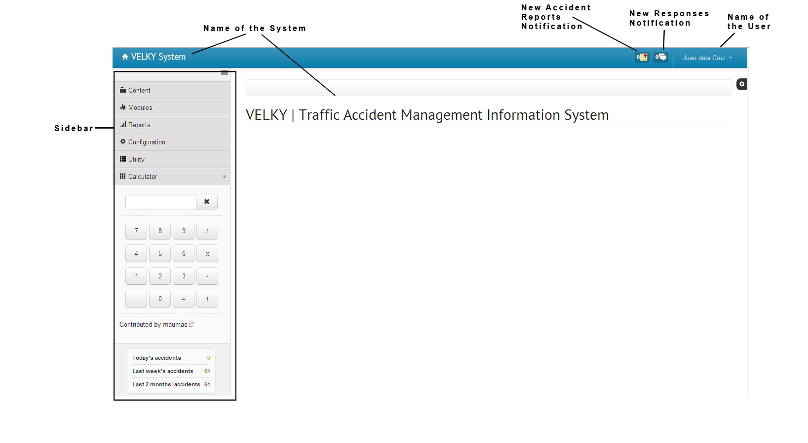

Screenshot shows the Filtered Report dialog box in Accidents category under Reports menu.

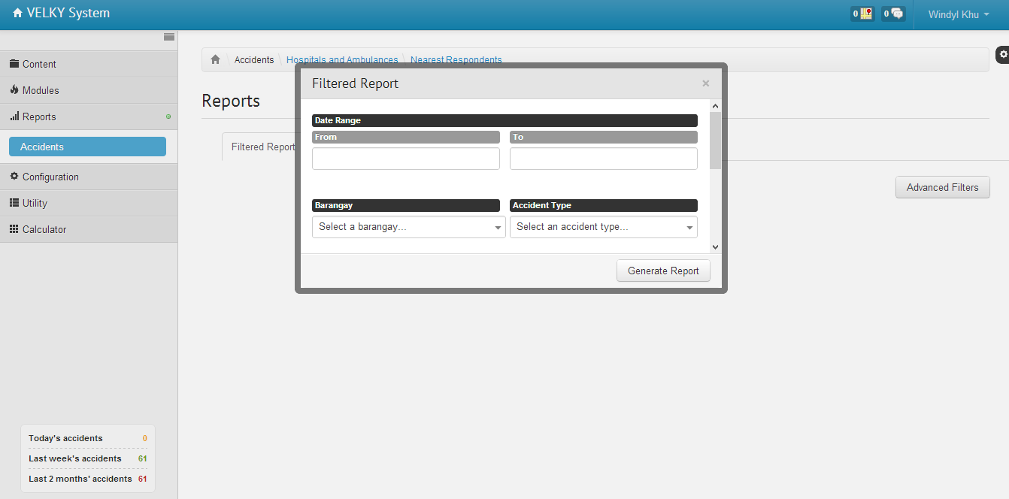

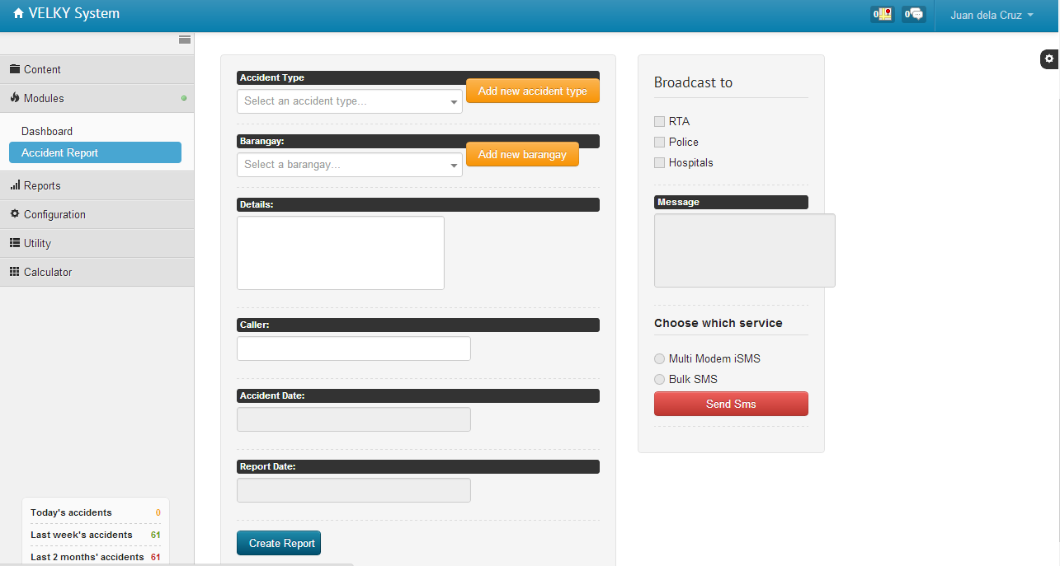Screenshot shows Accident Report page under Modules Menu

Screenshot shows Accident Types master file under Utility menu.